Edinburgh & Lothians Miniature Railway Club
Colburgh

Club Contact Details
Website www.elmrc.org.uk
Email: secretary@elmrc.org.uk
Exhibiting:
The layout and operators can be transported in a car plus trailer.
Setting up or dismantling the layout takes around an hour.
We can supply barriers; please let us know if you require us to provide them.
The layout is equipped with lighting.
Layout Details:
Scale: N Gauge
Layout Size: 2.9m x 0.31m (9ft 6ins x 1ft 0ins)
The above dimensions are excluding barriers and operating space.
Please allow 4 feet [1.2m] operating space along the back of the layout. We prefer a minimum of 2 feet [0.6m] between the layout and barriers. Please allow operator access to one end or back of the layout.
Operated: From rear, number of operating positions 1.
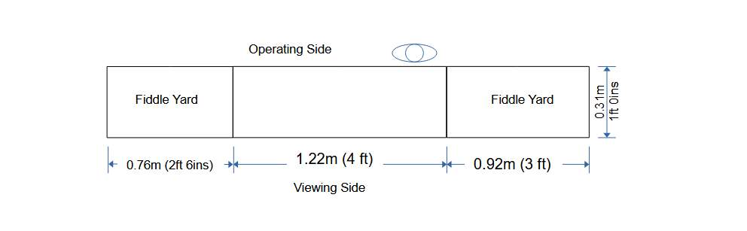

Description
Colburgh. N Gauge. Period late 1950s.
Colburgh is the penultimate station on a single line branch. While the line is a link for the local community it survives because it serves an (off scene) ferry terminal. Ferry services divide in the station and the ferry portion then passes under the road bridge on its way to the port. The front line, beyond the station, serves the goods yard and a factory but goes no further.
Control is conventional DC cab control.
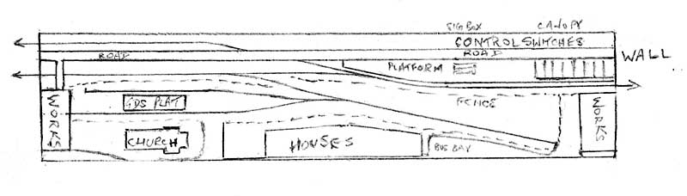
Track Plan

